NSAA/ENOA BASKETBALL
OFFICIALS’ CLINIC

The NSAA/ENOA will be conducting a 3-Person Basketball Officials’ Clinic on November 24, 2007. The purpose of the camps is to train officials in 3-person mechanics. The NSAA/ENOA began using 3-person officiating for all post- season contests in 2007. The clinic will consist of classroom instruction followed by court time observation and evaluation. Officals interested in 2008 post season assignments should have attended a 3-person mechanics clinic.

3-Person Mechanics Clinic Lincoln North Star High School November 24, 2007

Classroom: 8:00 aM – 9:00 AM

Court Time: 9:00 AM -- ???

Registration Fee; $ 35.00 Non-Refundable
Lunch will be provided
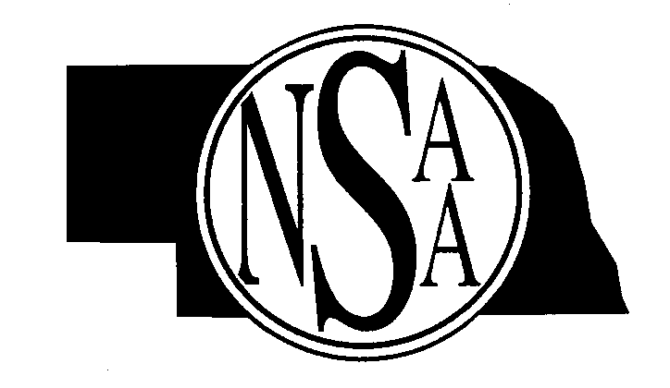
Evaluators and Clinicians: ENOA
Dick Zierke rzierke@neb.rr.com
Shane Smith ssmith6@neb.rr.com
Willie Beamon nyg21db@gmail.com

Clinic will be limited to first 50 applicants.
_______________________________________________________________________________________________________
North Star Clinic November 24, 2007
Complete the registration forms with all the necessary information and enclose payment of $35.00.

Return by November 16, 2007

Name____________________________________Address___________________________________________________

City____________________________State______Zip_____________________Telephone # ________________________

E-mail _____________________________

MAIL TO: NSAA
P.O. Box 5447
Lincoln, NE 68505-0447

